NH Public Utilities Commission

CEPS Portal User Manual
Smith, Weston
8/17/2017

Contents
NH Public Utilities Commission 0
1. General Information 2
1.1. System Overview 2
1.2. User Access Levels 2
2. Getting Started 2
2.1. Supplier Account Management 2
2.1.1. Adding A New User To Your Company Profile 2
2.1.2. Removing A User Account 3
2.1.3. Adding A Plan 4
2.1.4. Updating A Plan 6
2.1.5. Removing A Plan 7
2.1.6. Updating Supplier Account Information 8
2.2. Utility Account Management 9
2.2.1. Account Management 9
2.2.2. Adding A New User To Your Company Profile 11
2.2.3. Removing A User Account 12
3. Definitions 12
3.1. Supplier Input Definitions 13
3.1.1. Supplier Plan Management 13
3.1.2. Supplier Account Management 13
3.2. Utility Input Definitions 13
3.2.1. Utility Account Management 13

General Information
The competitive energy supplier portal was created to provide competitive energy suppliers (CEPS) the ability to easily manage and maintain their energy pricing and company information on the PUC.NH.GOV Comparison Shopping Webpage for Competitive Electric Supply (PUC.NH.GOV Shopping Page).

Information on the comparison shopping page must be updated as product offerings and prices change and no less frequently than once a month. The CEPS are responsible for the accuracy of the information provided.

System Overview

Depending upon whether you are a CEPS or a Utility, the management options that are available to you will differ. Skip to the section that is relevant to your account type.

User Access Levels
A CEPS or Utility may have multiple user accounts. All user accounts have access equally to all configurable information. The CEPS or Utility may have no more than 5 user accounts active at any given time. All user accounts can add or remove other user accounts without limitation.

Getting Started

CEPS Account Management
The following section is relevant to CEPS user accounts. The below functionality is available to all of the CEPS’s user accounts.

Adding A New User To A CEPS Profile
Note: When registering a new user account to your company’s profile, the user will receive a registration email with a link to complete their registration. Please allow up to 24 hours for this email to be sent.
- Click User Management > Add User in the navigation menu.
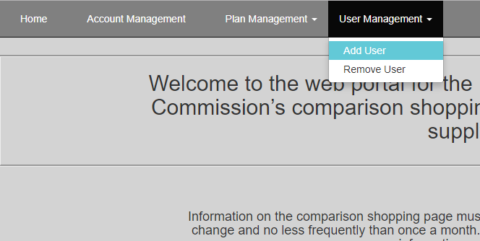

- Enter the email address of the user you wish to have registered for your company.
- 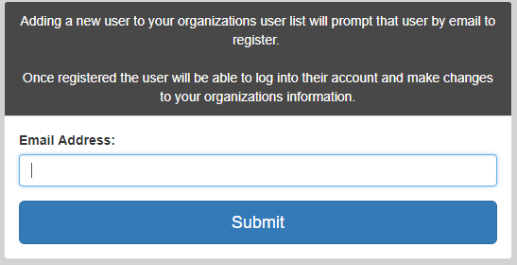

- Click Submit.

- Complete!

Removing A User Account
- Click User Management > Remove User from the navigation menu.
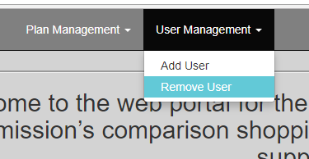

- Select the user you wish to remove and click Remove.
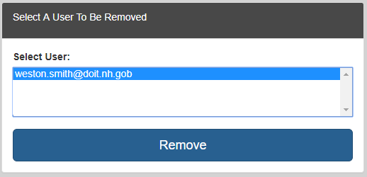

- Complete!
Note: Once a user account is removed, the company must go through the New User registration process described in 2.1.1 to create a valid user account again.

Adding A Plan
- Select Plan Management > Add Plan from the navigation menu.
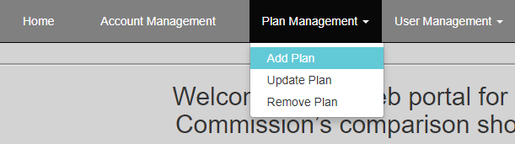
- Select a utility from the list of available utilities and fill out the new plan form.
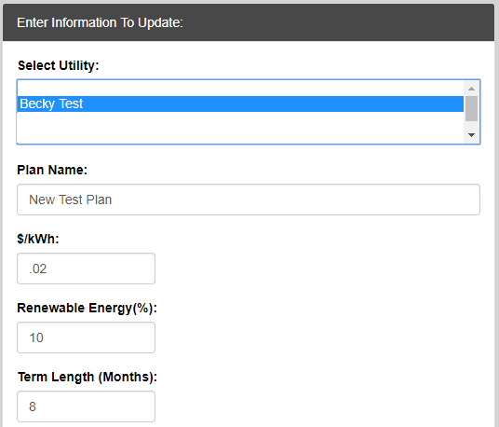

- Click Submit.
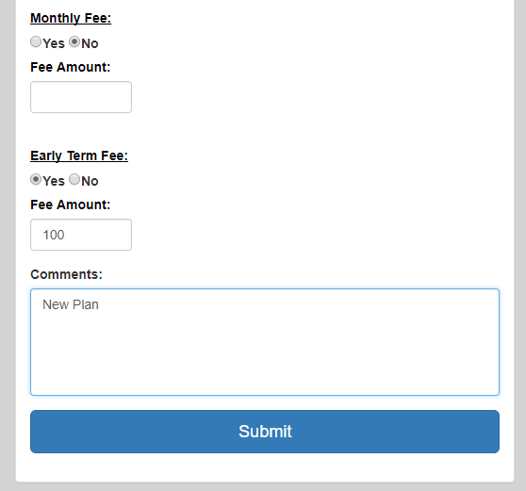
- Complete!

Updating A Plan
- Select Plan Management > Update Plan from the navigation menu.
- Select the utility that the plan you wish to update belongs to, then select the plan under that utility.
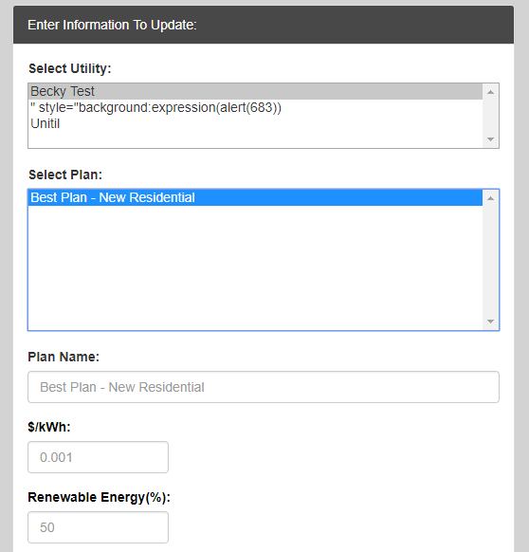
- After making any necessary changes, click Submit.
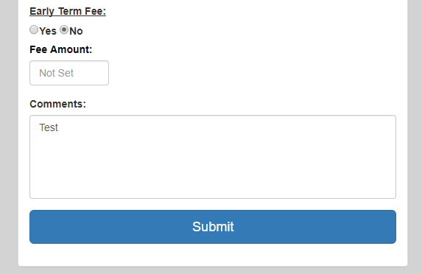

- Complete!

Removing A Plan
- Click Plan Management > Remove Plan from the navigation menu.
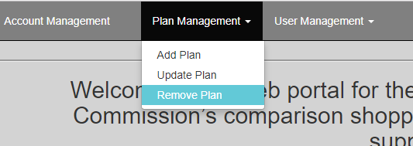
- Select the utility the plan belongs to, and then select the plan.
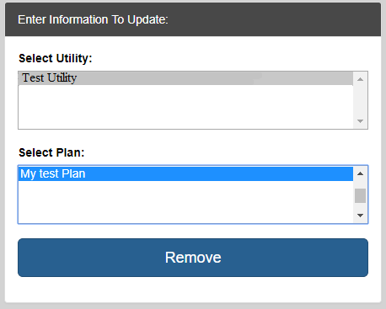
- Click Remove.
- Complete!

Updating Supplier Account Information
- Click Account Management from the navigation menu.
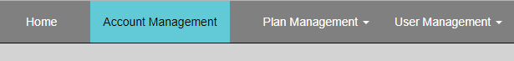
- Make any necessary changes and click Submit.
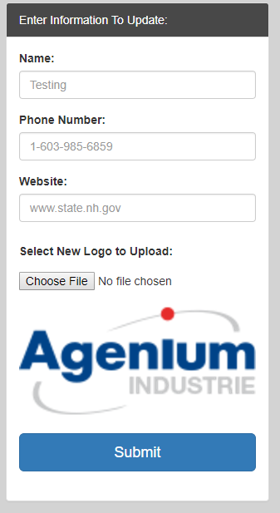
- Complete!

Utility Account Management
The following section is relevant to Utility user accounts. The below functionality is available to any Utility user account.

Account Management
- Click Account Management from the navigation menu.
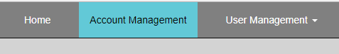
- Make any necessary changes and click Submit.
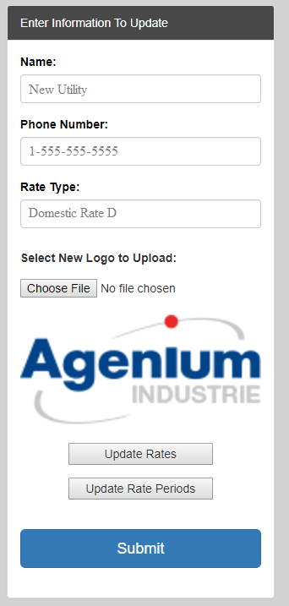
- Complete!

Adding A New User To A Utility Profile
Note: When registering a new user account for a Utility, the user will receive a registration email with a link to complete their registration. Please allow up to 24 hours for this email to be sent.
- Click User Management > Add User in the navigation menu.

- Enter the email address of the user you wish to have registered for your company.

- Click Submit.

- Complete!

Removing A User Account
- Click User Management > Remove User from the navigation menu.

- Select the user you wish to remove and click Remove.

- Complete!
Note: Once a user account is removed, the Utility must go through the New User registration process described in 2.2.1 to create a valid account.

Definitions
This sections aims to describe the inputs for certain pages and their meanings. Skip to the section that is relevant to your user account type. (Utility or CEPS)

CEPS Input Definitions
The following is a description of the inputs on several CEPS-related pages.

CEPS Plan Management
The Plan Management page is used to update or add the CEPS’s plan information on the NH.PUC.GOV Shopping Page. The “Add” and “Update” pages have the following inputs.
- Plan Name – The desired name of the plan.
- $/kWh – the rate associated with the Plan in dollars per kilowatt hour.
- Renewable Energy (%) – Percentage of energy for the plan that comes from renewable energy resources.
- Term Length – The length that the plan is active (in months).
- Rate End Date – The date in which the Plan’s rate ends.
- Customer Type – The type of customer that this plan is available to.
- Rate Type – Fixed rate or Variable rate.
- Intro Price – Whether or not the plan has an introductory price.
- Intro Good For (Days) - The length of time in days that the introductory price is valid.
- Monthly Fee - Whether or not the plan has a monthly fee.
  - Fee Amount – Monthly fee amount.
- Early Term Fee – Whether or not the plan has an early termination fee.
  - Fee Amount – The early termination fee amount.
- Comments – Any additional comments regarding the plan.

CEPS Account Management
The CEPS Account Management page is used to manage the CEPS’s account profile as it appears on the NH.PUC.GOV Shopping Page. The Account Management page has the following inputs.
- Name – The name of the CEPS.
- Phone Number – The contact phone number for the CEPS.
- Website – The address of the CEPS’s web page.
- Logo – The logo for the CEPS as it appears on the NH.PUC.GOV Shopping Page.

Utility Input Definitions
The following is a description of the inputs on the Utility Account Management page.

Utility Account Management
The Utility Account Management page is used to manage the Utility’s account profile as it appears on the NH.PUC.GOV Shopping Page. The Account Management page has the following inputs.

- Name – The name of the Utility as it appears on the NH.PUC.GOV Shopping Page.
- Phone Number – The contact phone number for the Utility.
- Rate Schedule – The rate schedule for the Utility.
- Logo – The logo for the Utility as it appears on the NH.PUC.GOV Shopping Page.
Update Rates
- Current Residential Price – The current rate for Residential customers.
- Current Small Commercial Price – The current rate for Small Commercial customers.
- Future Residential Price – The future rate for Residential customers.
- Future Small Commercial Price – The future price for Small Commercial customers.
Update Rate Periods
- Current Rate Begin Date – The beginning date for the current price.
- Current Rate End – The ending date for the current price.
- Future Rate Being Date – The beginning date for the future price.
- Future Rate End Date – The ending date for the future price.

